Required files.
1) 2+ xml
1) One ApplicationContext.xml defines joblauncher and jobrepository for all batch jobs,
2) One Batch.xml for each batch job
2) 1 POJO
Steps in Spring
- BATCH XML SIDE
- A batch Job is composed of one or more Steps. Ex: A job read data from DB, generates XML and do clean up. Here 3 steps are present.
- The steps are represented by JobInstance, So here we will have 3 JobInstance with JobParameters.
- Each run of a JobInstance is a JobExecution.

- MAIN XML SIDE
- The application will have multiple Batchjobs. So, launching a specific Job with parameters is done by JobLauncher.
- SimpleJobLauncher implementation of JobLauncher, relies on a TaskExecutor to launch the jobs. If no specific TaskExecutor is set then a SyncTaskExecutor is used.

- JobRepository stores runtime information related to the batch execution.
- SimpleJobRepository implementation of JobRepository which requires a set of execution Daos to store its information. JobInstanceDao, JobExecutionDao, StepExecutionDao
These data access objects are used by SimpleJobRepository to store execution related information. Two sets of JobRepository implementations are provided by Spring Batch: 1) Map based (in-memory) and 2) Jdbc based (Store in database).

- JAVA SIDE
- A Tasklet is an object containing any custom logic to be executed as a part of a job.
- The execute method of Tasklet returns an RepeatStatus to indicate the status of the execution of the tasklet.

- We will define our first job now in a simpleJob.xml application context. We will use the SimpleJob implementation which executes all of its steps sequentailly. In order to plug a tasklet into a job, we need a TaskletStep.

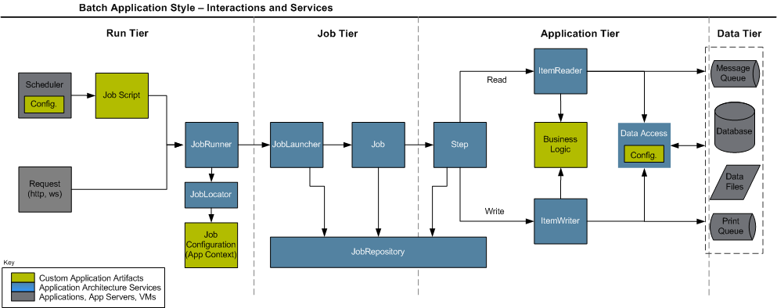

All batch processing can be described in its most simple form as
Reading in large amounts of data,
performing some type of calculation or transformation, and
writing the result out.
Spring Batch provides three key interfaces to help perform bulk reading and writing:
ItemReader,
ItemProcessor and
ItemWriter.

For JMS, a step doesn’t need to buffer data
Rollback and commit conventions in Spring and Java Enterprise Edition
Java defines two types of exceptions: checked and unchecked. A checked exception
extends the Exception class, and a method must explicitly handle it in a try-catch
block or declare it in its signature’s throws clause. An unchecked exception extends
the RuntimeException class, and a method doesn’t need to catch or declare it. You
commonly see checked exceptions used as business exceptions (recoverable) and
unchecked exceptions as lower-level exceptions (unrecoverable by the business logic).
By default, in Java EE and Spring, commit and rollback are automatically triggered by
exceptions. If Spring catches a checked exception, a commit is executed. If Spring
catches an unchecked exception, a rollback is executed. You can configure Spring’s
transactional support to customize this behavior by setting which exceptions trigger
commits and rollbacks.
Download from Wow! eBook <www.wowebook.com>
72 CHAPTER 3 Batch configuration
because JMS already provides this feature. For this type of resource, you need to specify
the reader-transactional-queue attribute on the corresponding chunk, as shown in
the following listing.
<batch:tasklet>
<batch:chunk reader="productItemReader"
reader-transactional-queue="true" (...)/>
</batch:tasklet>
<bean id="productItemReader"
class="org.springframework.batch.item.jms.JmsItemReader">
<property name="itemType"
value="com.manning.sbia.reader.jms.ProductBean"/>
<property name="jmsTemplate" ref="jmsTemplate"/>
<property name="receiveTimeout" value="350"/>
</bean>

The list of launching solutions this chapter covers is by no means exhaustive. The
Spring Batch launcher API is simple to use, so you can imagine building other types of
solutions—for example, event-driven with JMS or remote with Java Management
Extension (JMX). And don’t forget to read section 4.5 on stopping job executions
when you’re done launching all these jobs!

